SIDUHE BRIDGE

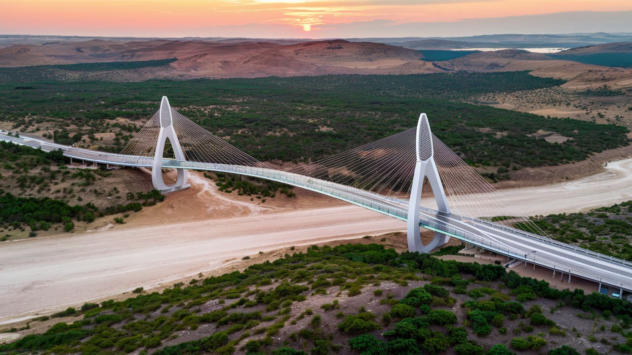

The Siduhe Bridge, also known as the Sidu River Bridge, is a remarkable feat of modern engineering located in the Hubei province of China. Stretching across the Sidu River Gorge, this suspension bridge holds several notable records and is renowned for its breathtaking height and length.

Completed in 2009, the Siduhe Bridge stands as the highest bridge in the world, with its deck soaring a staggering 496 meters (1,627 feet) above the river below. This height surpasses even that of the famous Millau Viaduct in France, making it a marvel of architectural and structural achievement.

In addition to its record-breaking height, the Siduhe Bridge boasts an impressive length of 1,222 meters (4,009 feet). Its mammoth span connects the steep cliffs on either side of the gorge, providing a vital transportation link between the remote regions of Enchi Tujia and Miao Autonomous Prefecture.